**STUDIO/ EFFICIENCY**

**E1**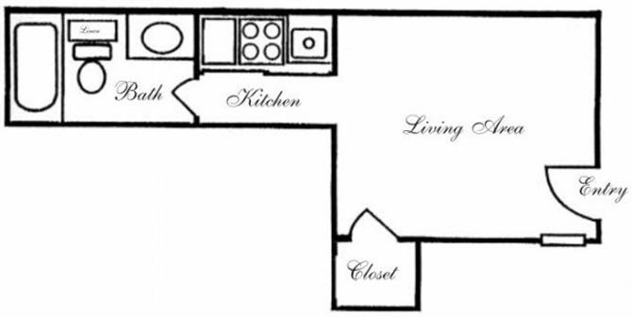

**282 square feet**

**E2**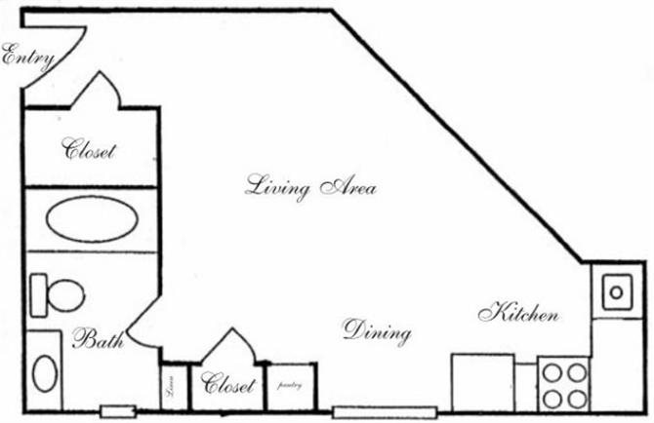

**343 square feet**

**E4**

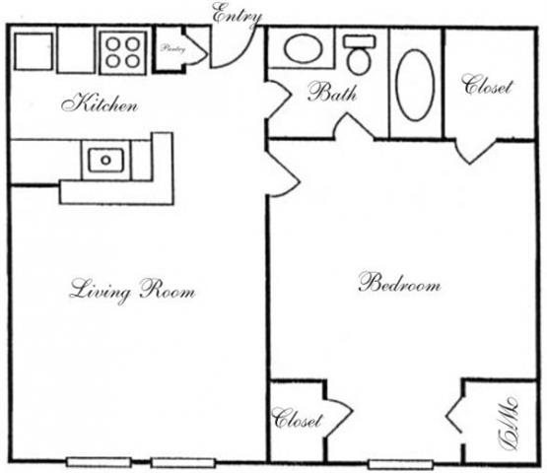

**441 square feet**

**E5**

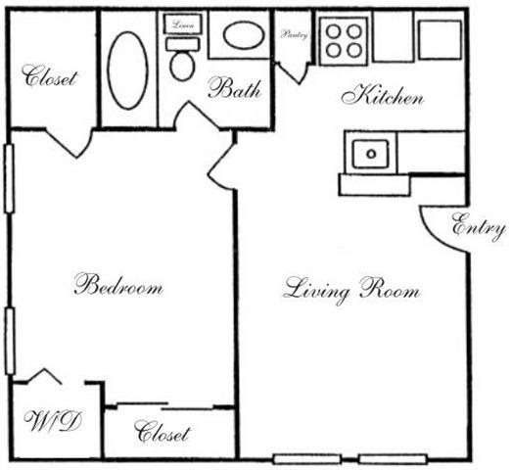

**518 square feet**