**1 Bedroom/ 1 Bath**

**AA**

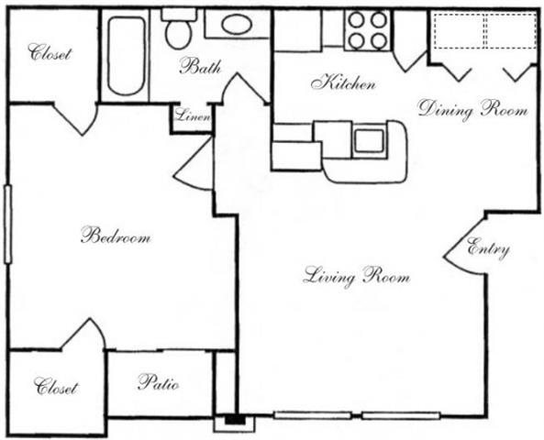

**622 Square Feet**

**A1**

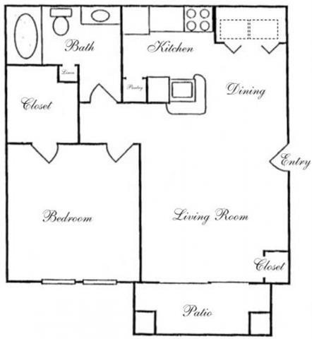

**625 Square Feet**

**A2**

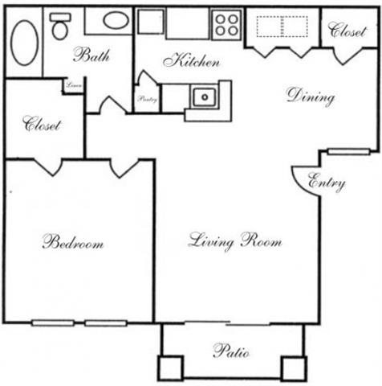

**663 Square Feet**

**A4**

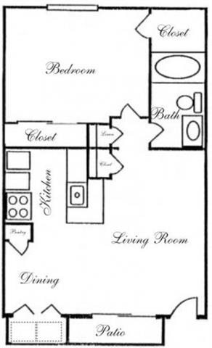

**670 Square Feet**

**A5**

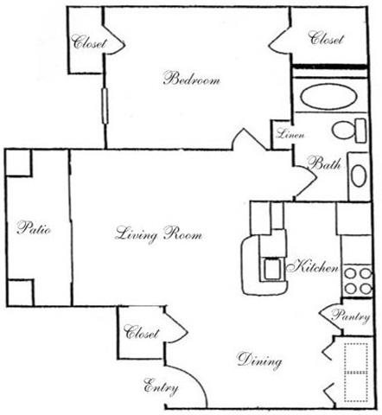

**677 Square Feet**

**A6**

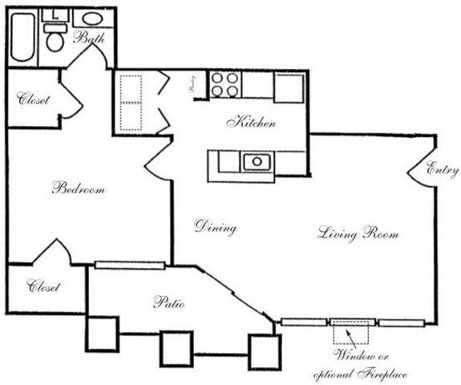

**680 Square Feet**

**A7**

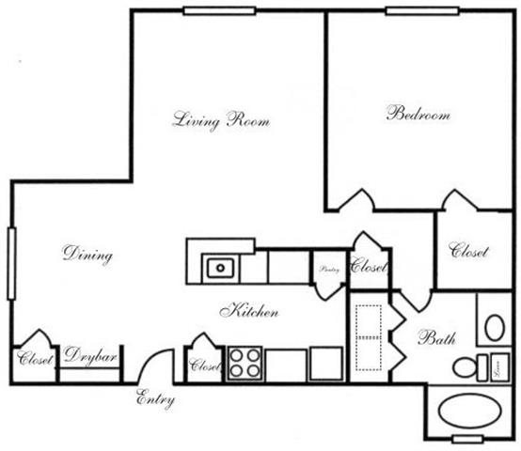

**730 Square Feet**

**A8**

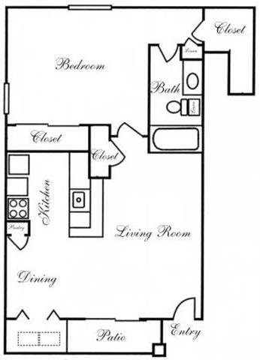

**750 Square Feet**

**A9**

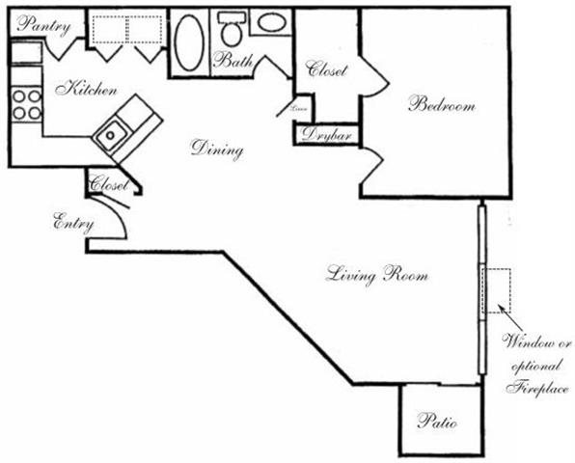

**813 Square Feet**

**AB**

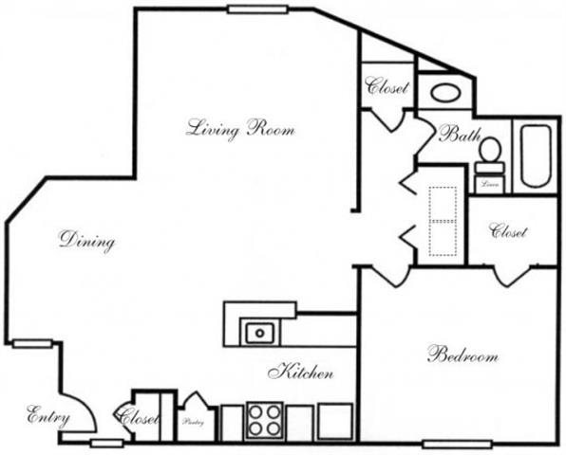

**831 Square Feet**